LSESL System Guideline

Ash Xu, Living Stone Academy, 2018.11.19

## Introduction

English as second language acquisition has always been a universal trouble for most Chinese students. Without neither suitable environments nor opportunities to practice, students generally maintain a fragmented English language system. While the technics they acquired in school help them pass the mainland exams, they are most likely to find themselves in an awkward situation when facing the DSE examination because they’ve developed their English language abilities in an unpractical and badly-organized way.

To right the wrongs, the LSESL system is designed.

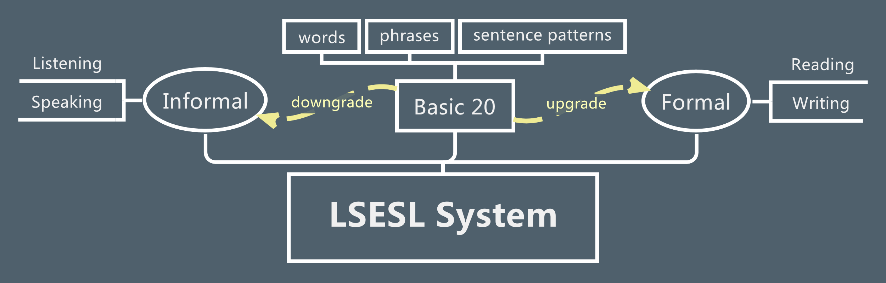

Aiming specifically toward high school students, the LESEL system is based on the mastery of high frequency words, phrases and basic sentence patterns taught in middle and high schools. Therefore, a prior test for the Basic 20 is necessary (the Basic 20 means the basic 20% of English language people used in 80% of situations). And correspondent courses should be properly prepared to ensure mastery in the Basic 20 for weak students who fail the Basic 20 test.

When the Basic 20 is secured, it’s time to extend the English language learning to a higher level, which can be defined as two categories, downgrading and upgrading. Downgrading means the informalization of language usages, which generally happens in listening and speaking, while Upgrading means the formalization of language usages, which generally happens in reading and writing. In that, the following-on courses will be designed in two opposite directions and each will focus on their own contexts.

Apart from the above, the whole system should be DSE-oriented, which means the abilities to be acquired should be practical and well-organized. To achieve that goal, all the courses designed in LSESL System should obey the universal principle, which is, to teach between knowledges, and to teach beyond knowledges. Only then, will it be possible to educate students to be independent thinkers and discoverers.

Simply put, the LSESL System is a robust and wholistic English language acquisition method, and yet also an unfinished book, with the rest of it to be completed by students themselves. **Whatever future of *living* you wish to build, we prepare the *stones* for you.**